# 1. Project Proposal

Adventure Cymru has asked me to create a digital product that will showcase an activity that they provide. As shown by the survey they conducted, Kite Surfing was the most popular activity at a target audience of ages 10 to 13. I will be making a 30 second animation at 24fps with characters and sounds to make the animation interesting and eye-catching.

After some research into kitesurfing, I have come up with a baseline of what the animation needs to cover:

1. Learning on the correct board – Trainer board
2. Flying a kite on land – launching, landing and controlling the kite
3. Flying a kite in water – Body dragging, control and re-launching
4. Getting up & riding on the board

The maximum length of the animation can be 30 seconds, and the main target of the animation is to show the viewer how fun kite surfing is. Therefore, the animation will include the following:

* A kite surfer arriving at the beach
* They will then practise kite control on the beach before entering the water
* They’ll practise body dragging and re-launching
* Then finally they will ride the board

| **Date:** | 10-03-22 |
| --- | --- |
| **Section worked on:** | Wireframe planning |
| **Work Completed:** |

# 2. Website

## 2.1. Designs

### 2.1.1 Layout (Master) Page

#### 2.1.1.1 Design 1

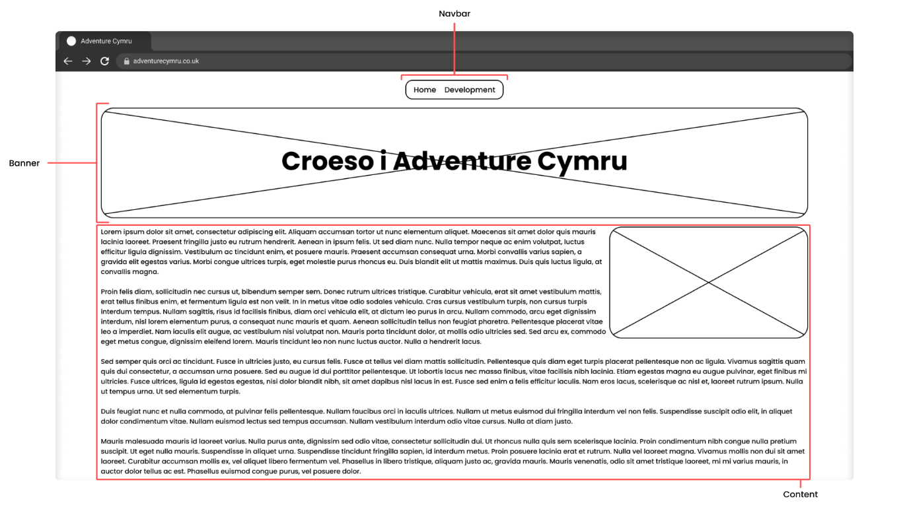

#### 2.1.1.2. Design 2

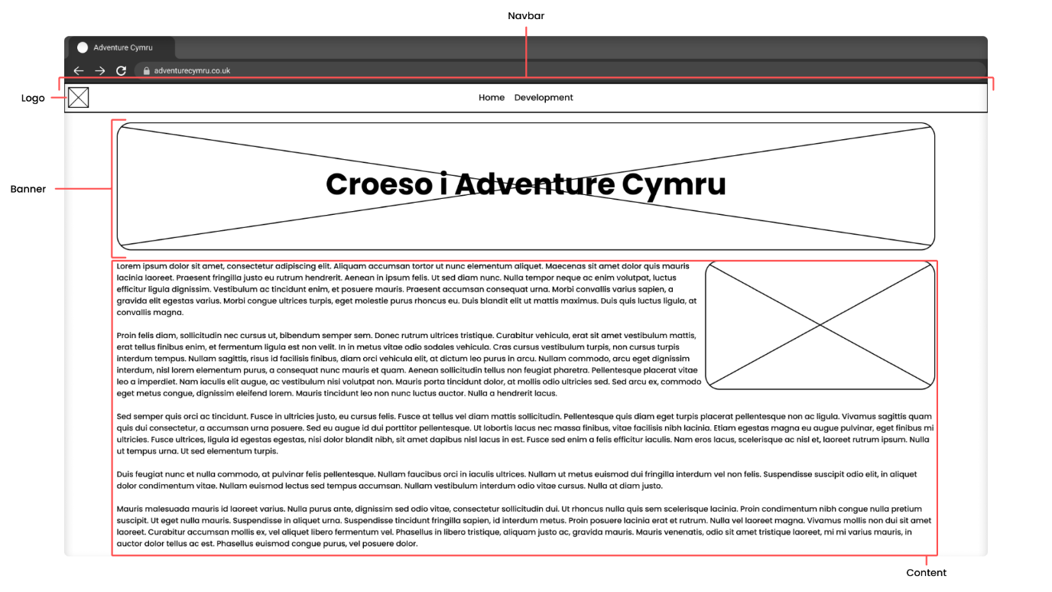

#### 2.1.1.3. Design 3

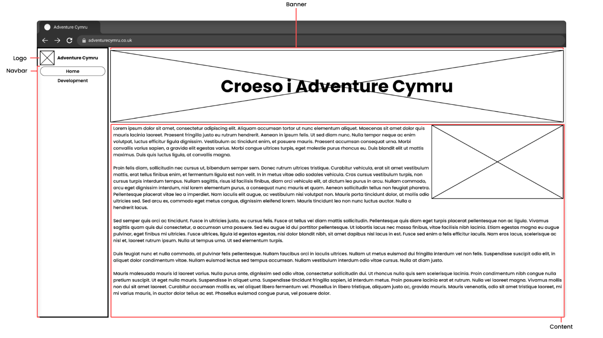

### 2.1.2. Index Page

#### 2.1.2.1. Design 1

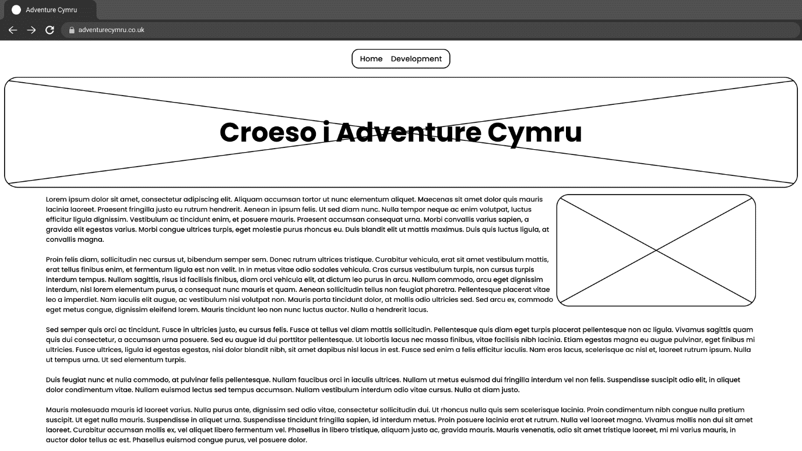

#### 2.1.2.2. Design 2

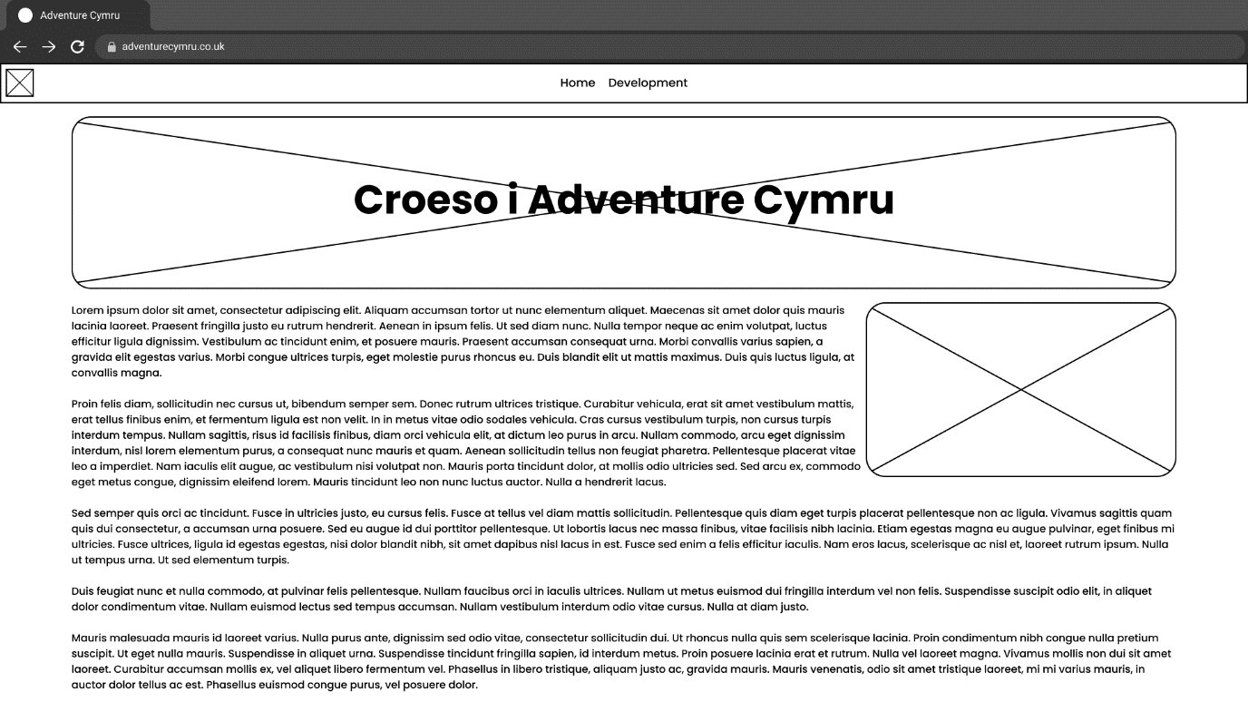

#### 2.1.2.3. Design 3

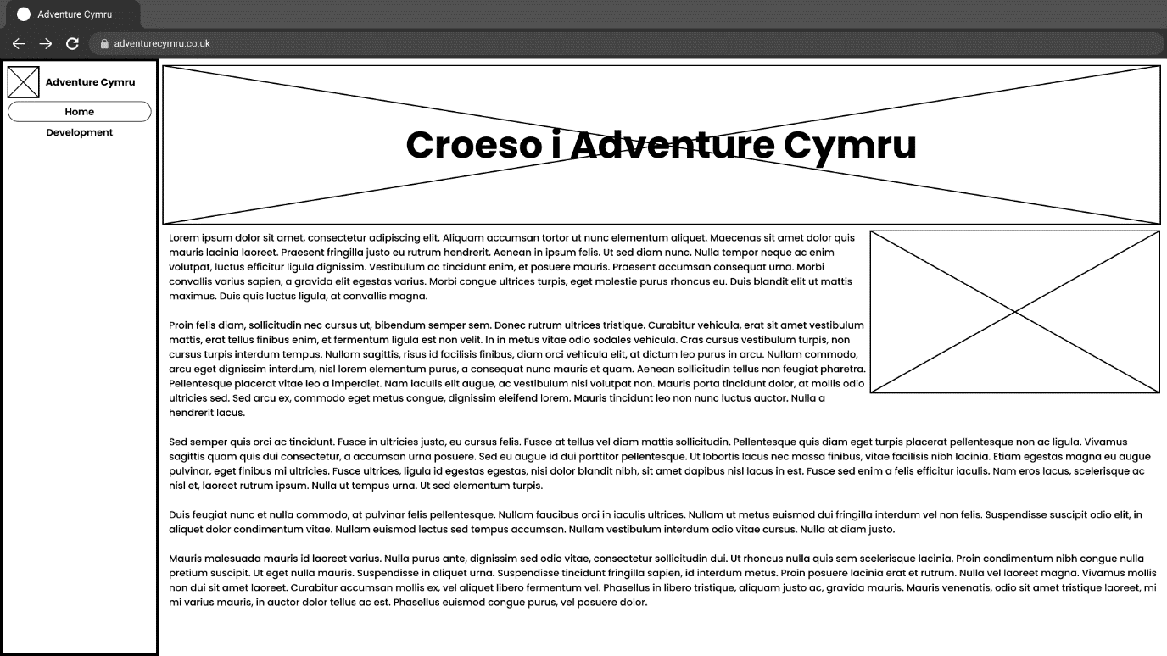

### 2.1.3. Development Page

#### 2.1.3.1. Design 1

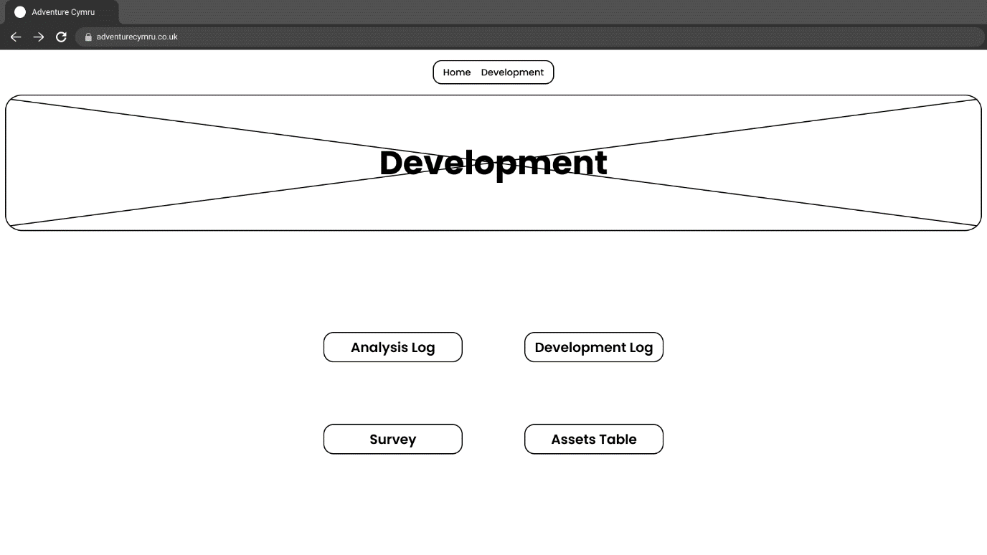

#### 2.1.3.2. Design 2

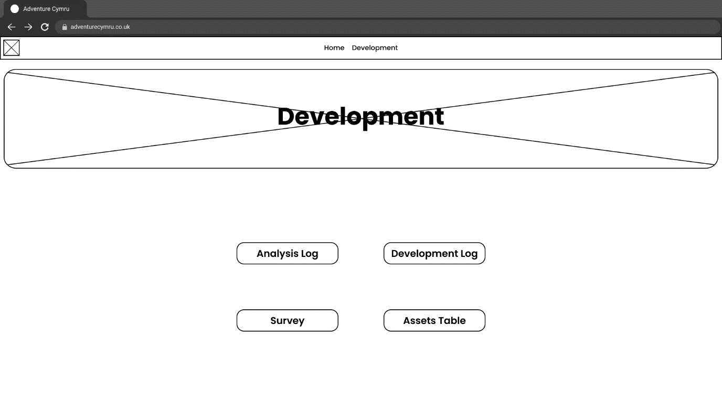

#### 2.1.3.3. Design 3

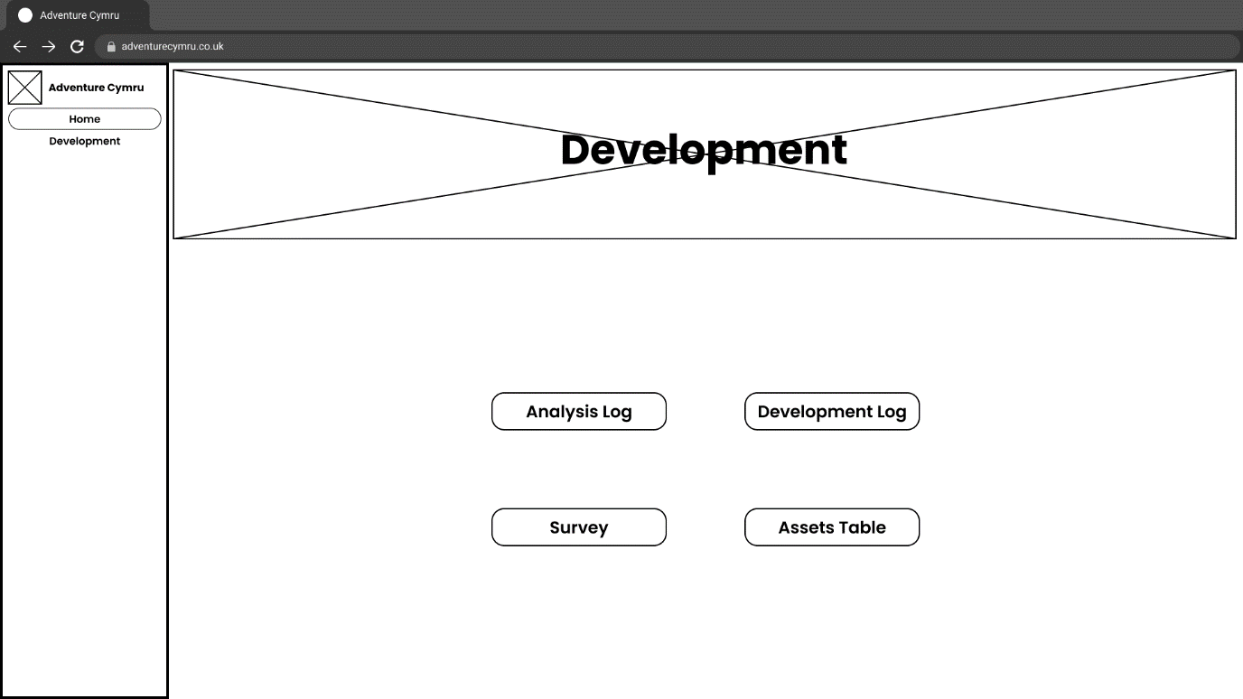

### 2.1.4. Animation Page

#### 2.1.4.1. Design 1

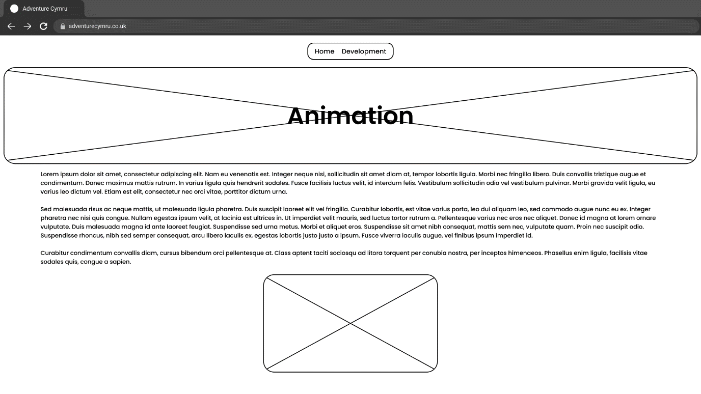

#### 2.1.4.2. Design 2

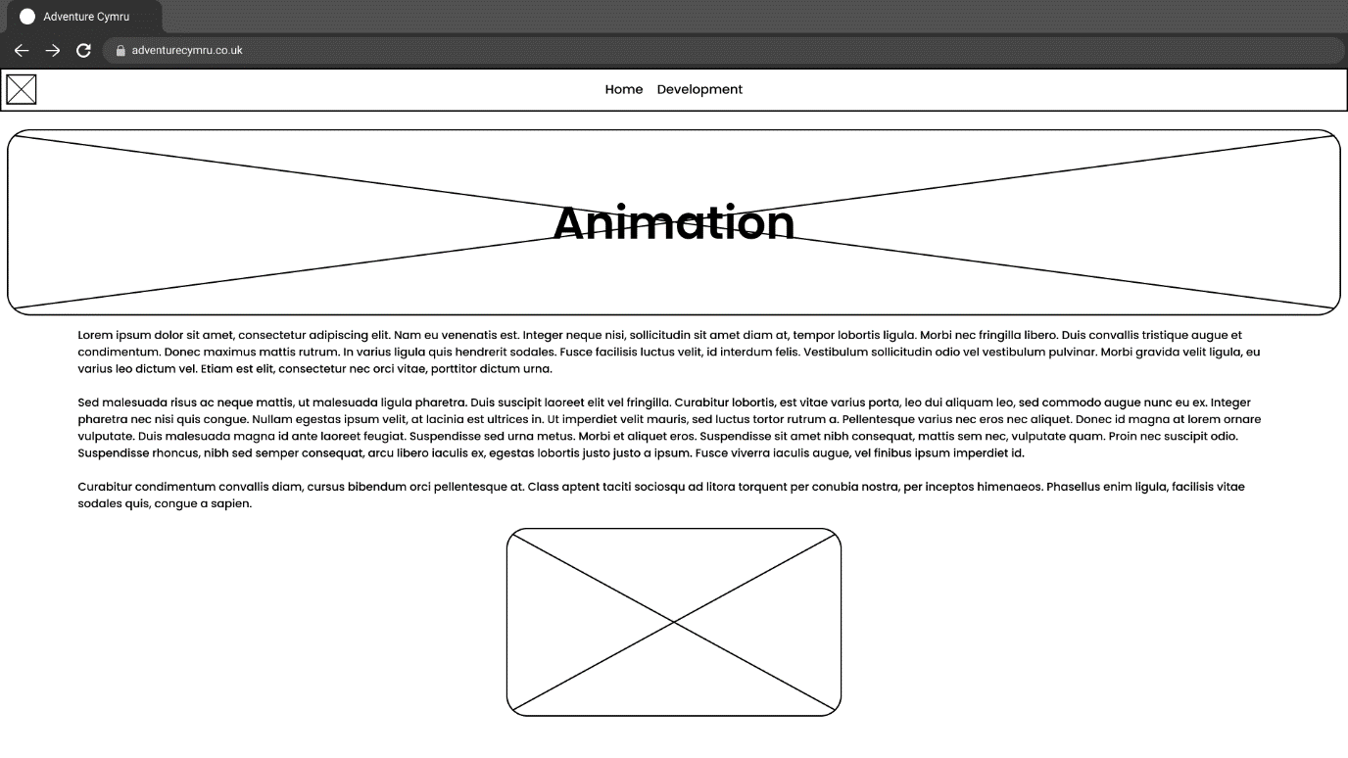

#### 2.1.3.3. Design 3

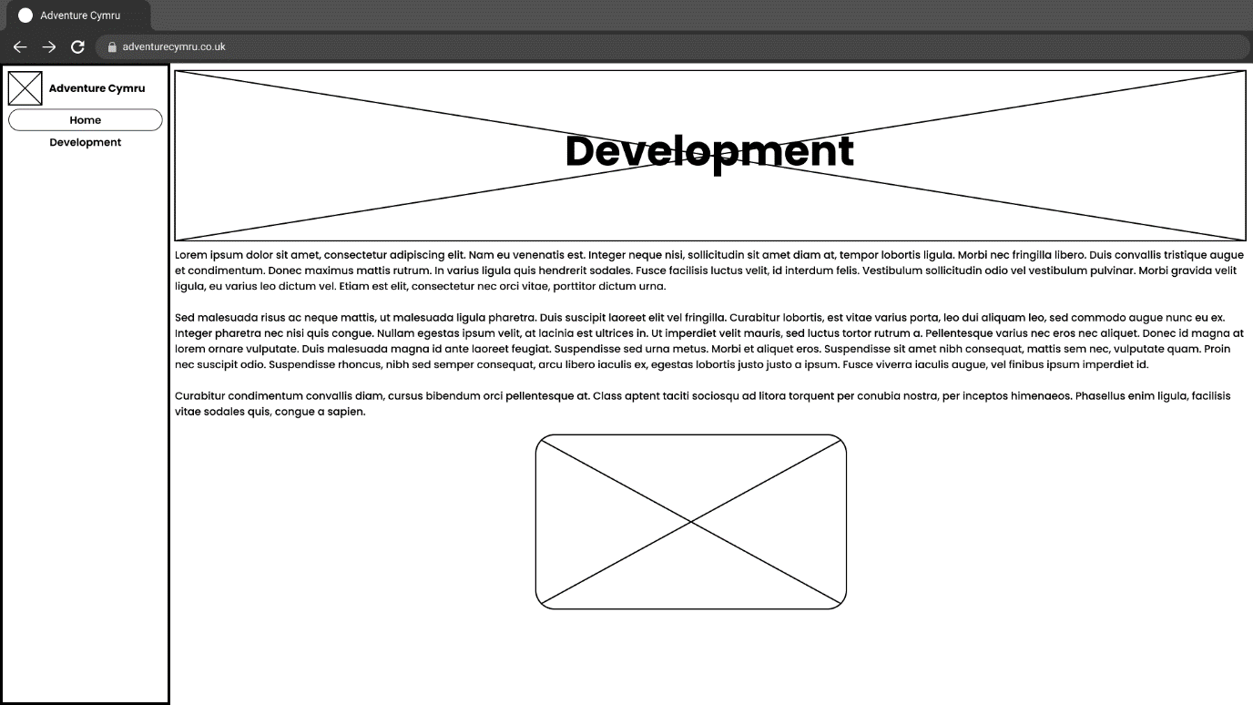

| **Date:** | 10-03-22 |
| --- | --- |
| **Section worked on:** | Colours & Fonts |
| **Work Completed:** |

## 2.2. Colour Scheme Options

### 2.2.1. Option 1

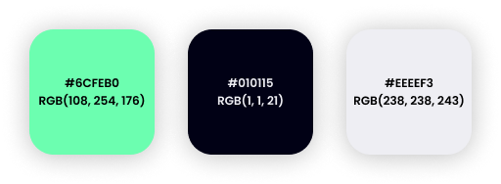

### 2.2.2. Option 2

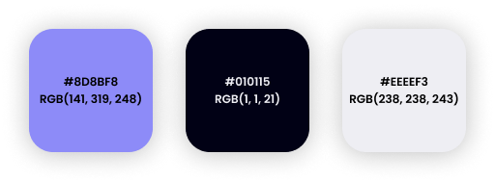

### 2.2.3. Option 3

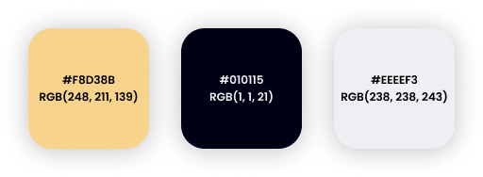

### 2.2.4. Background & Text Colour Combinations

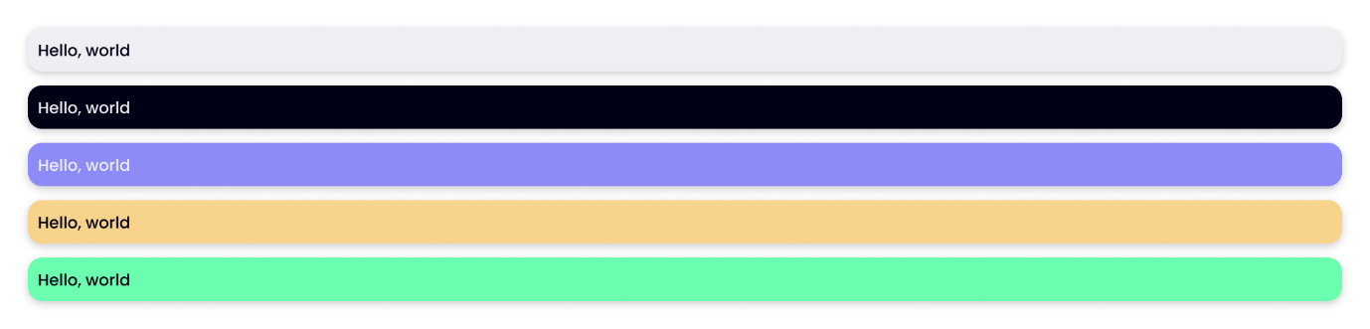

## 2.4. Fonts

I will be using [fonts.google.com](http://fonts.google.com) to find fonts and using fonts (in brackets) as a fall-back if the font is not supported or cannot be loaded.

To find fonts, I will use [fonts.google.com](http://fonts.google.com). If the selected font cannot be retrieved from their servers for whatever reason, a fallback font (in brackets) will be used. CSS allows for certain keywords in the font-family property, such as serif, sans-serif and monospace, which find the closest match on the users’ system.

* [Poppins](https://fonts.google.com/specimen/Poppins) – <h1-h6 /> (sans-serif)
* [Montserrat](https://fonts.google.com/specimen/Montserrat) (sans-serif)
* [Ubuntu](https://fonts.google.com/specimen/Ubuntu) (sans-serif)
* [Roboto Mono](https://fonts.google.com/specimen/Roboto+Mono) (monospace)
* [Playfair Display](https://fonts.google.com/specimen/Playfair+Display) - <p /> (sans-serif)
* [Rubik](https://fonts.google.com/specimen/Rubik) (sans-serif)

## 2.5. Flowchart of website links

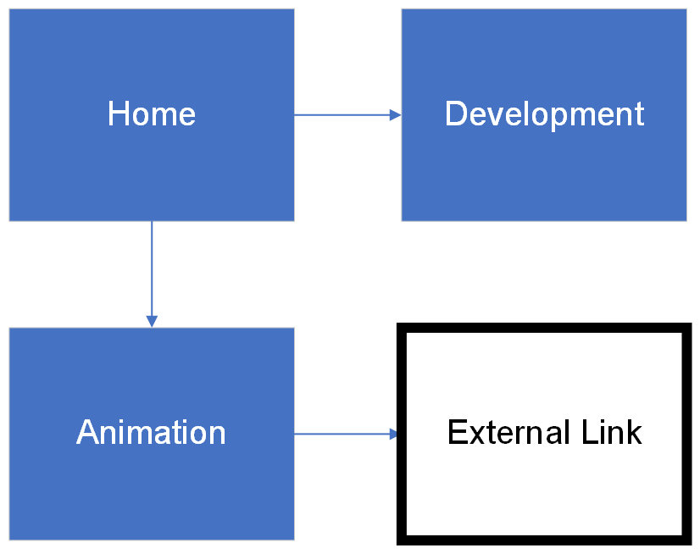

## 2.6. Content

* I will be formatting with [Markdown](https://www.markdownguide.org/cheat-sheet/#%5D) syntax
* Bold items will be “dynamic” and change based on certain variables (time of day, etc) using JavaScript
* All H1 (one hashtag) elements will be displayed in the website's banner. Any other Heading elements (more than 1 hashtag until 6) will be within the main body.

### 2.6.1. Home

# **{Bore da,Prynhawn da,Nos da}**! We’re Adventure Cymru.

## Who are we & what do we do?

Here at Adventure Cymru, we provide action-packed adventures for those visiting (or even living in) Wales. This can be for family activities, birthday parties, school trips & more! We offer a range of activities including our customer-favourite, [kite surfing](/activities/kite-surfing)!

## Customer reviews

// Carousel of customer reviews

### 2.6.2. Kitesurfing

# Kitesurfing

## What is kitesurfing?

Kitesurfing is a wind-powered water surface sport where you stand on a board and use a kite to move across the surface of the water. The kite uses the wind to propel you forward.

## Skills & attributes for kitesurfing

- Relatively good fitness (especially in the core)

- Swimming ability

- Good confidence in yourself & trying new things

- The ability to stay calm

## Learning to Kitesurf

At Adventure Cymru, when you’re learning to kitesurf, you will go through 3 steps:

1. Flying a kite on land (how to launch, land & control a kite)
2. Flying a kite in the water (body dragging, control & re-launching)
3. Standing on & riding on a board in the water

These steps will also give you experience in:

- Assessing an area to make sure it is safe to kite

- Understanding wind direction

- Understanding tides, currents & hazards

- Choosing the right equipment

- Setting-up, tuning & packing away your equipment

- Safety procedures

- What to do in an emergency

- Board-starts (standing up on the board)

- Continuous riding

- Speed control

- Rules & rights-of-way in the water

## What equipment do I need to Kitesurf?

- A kite

- A control bar

- A seat (beginners) or waist harness (more advanced)

- A safety leash

- A large kite board

- A helmet

- Water shoes

- A Wetsuit

## 2.7. Feedback

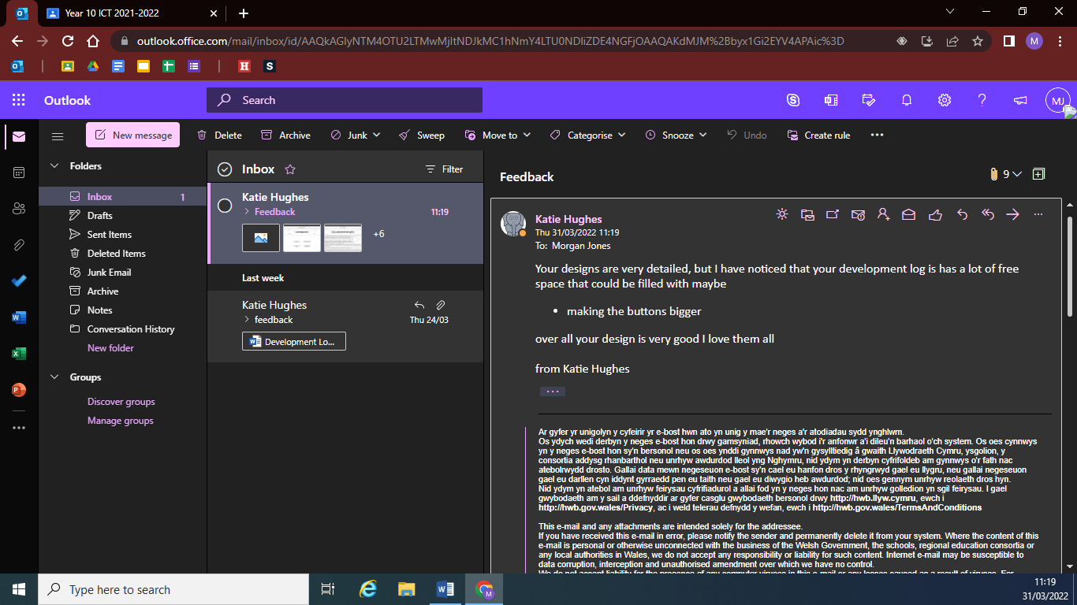

***Correction:*** *Development page\**

As stated in the feedback above, I should make my Development Log, Analysis Log, etc. buttons bigger. When creating the website I will keep this in mind and maybe expand these buttons, possibly with an image or preview of the file.

## 2.8. Final Product

To create the final website, I am making use of the [SvelteKit](http://kit.svelte.dev) framework, with the Visual Studio Code text editor. I will be using [TypeScript](http://typescript.dev) as my programming language, due to its improvements over the dynamically-typed JavaScript. The source code and instructions for running the website is hosted on my [Github Page](https://github.com/morganjones-dev/adventure-cymru).

## 2.8.1. Development Process

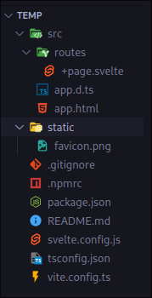

*Freshly initialised SvelteKit Project*

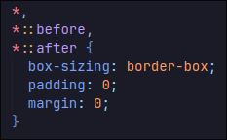

*Basic CSS resets*

**

*Created _vars.scss file*

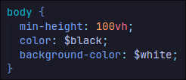

*Basic body CSS*

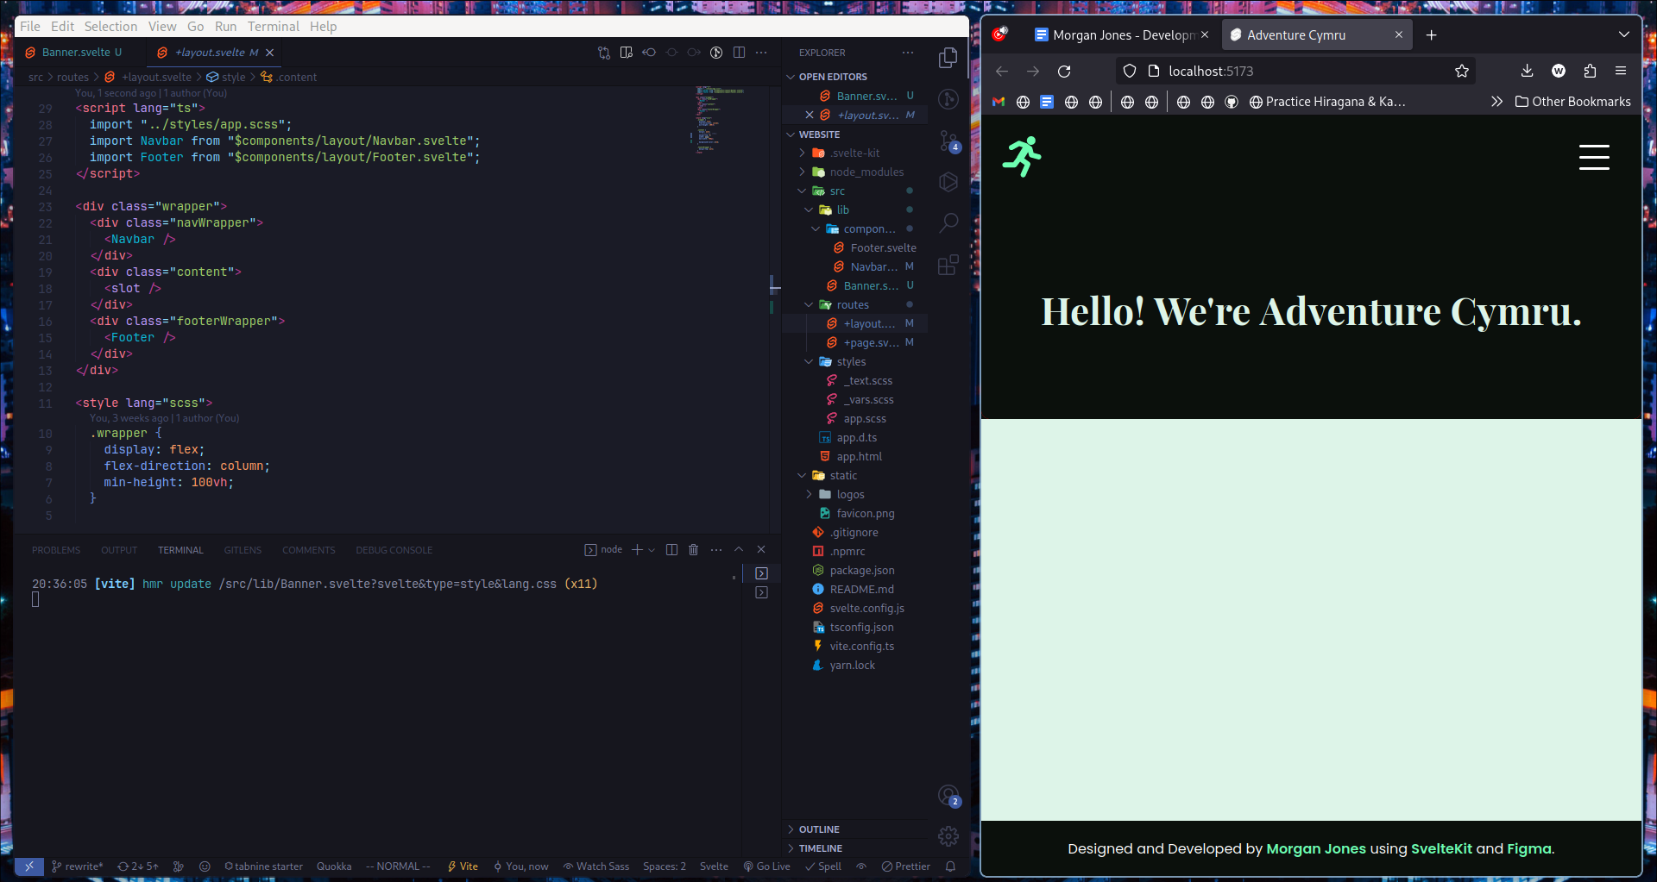

*Mobile layout*

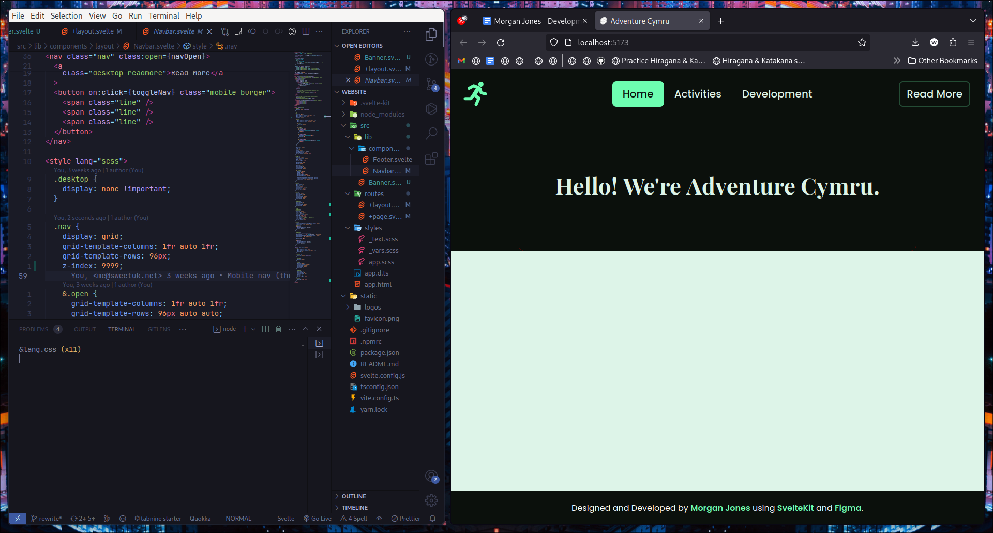

*Desktop layout*

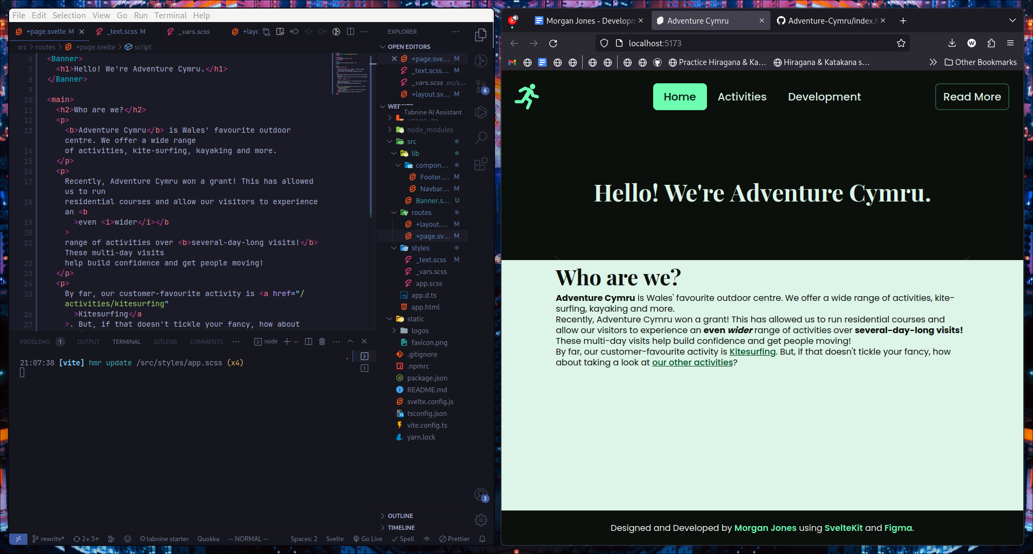

*Added Home page content*

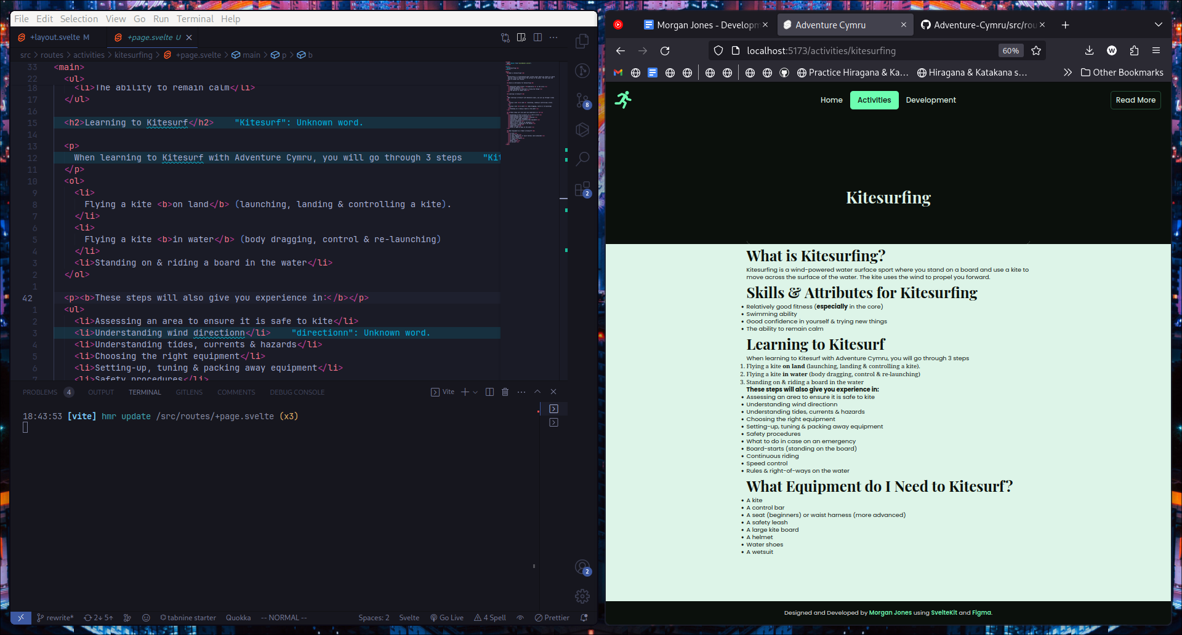

*Added Kitesurfing page content*

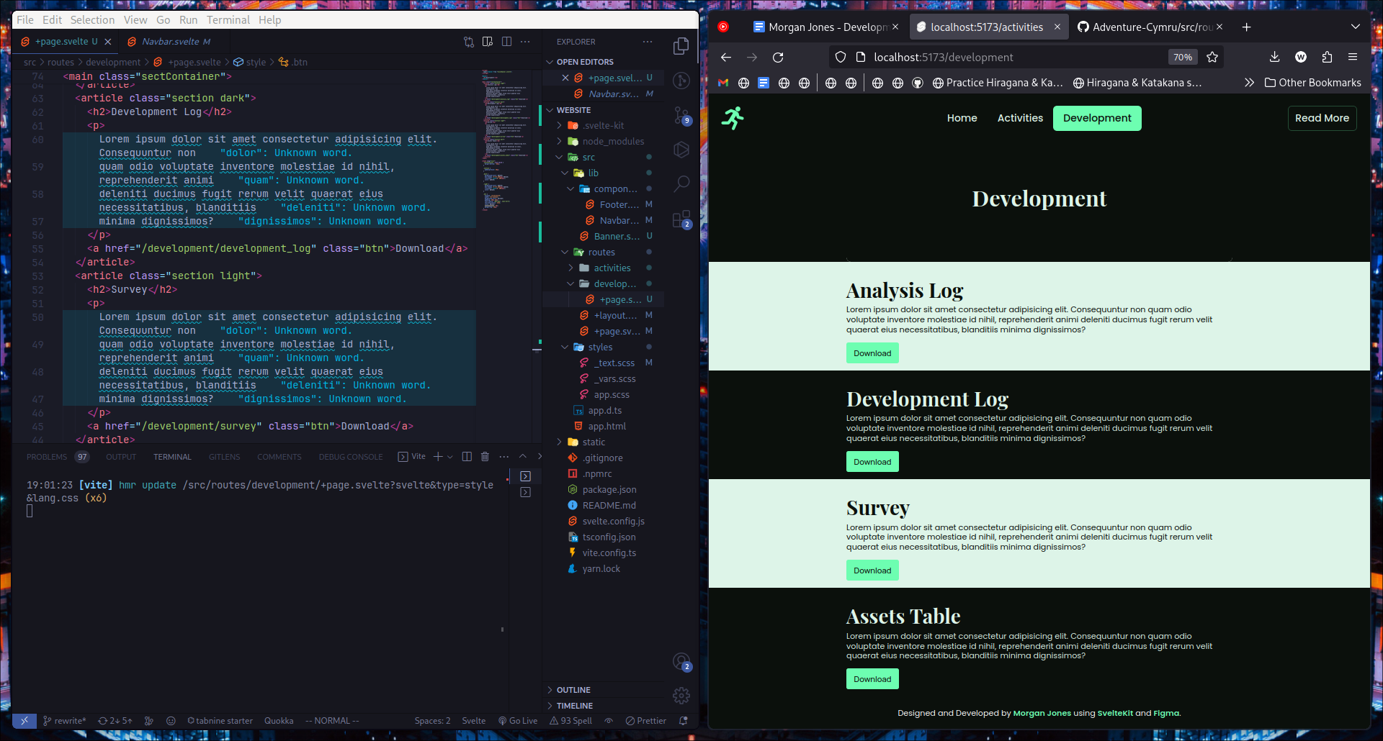

*Development log page (with example content)*

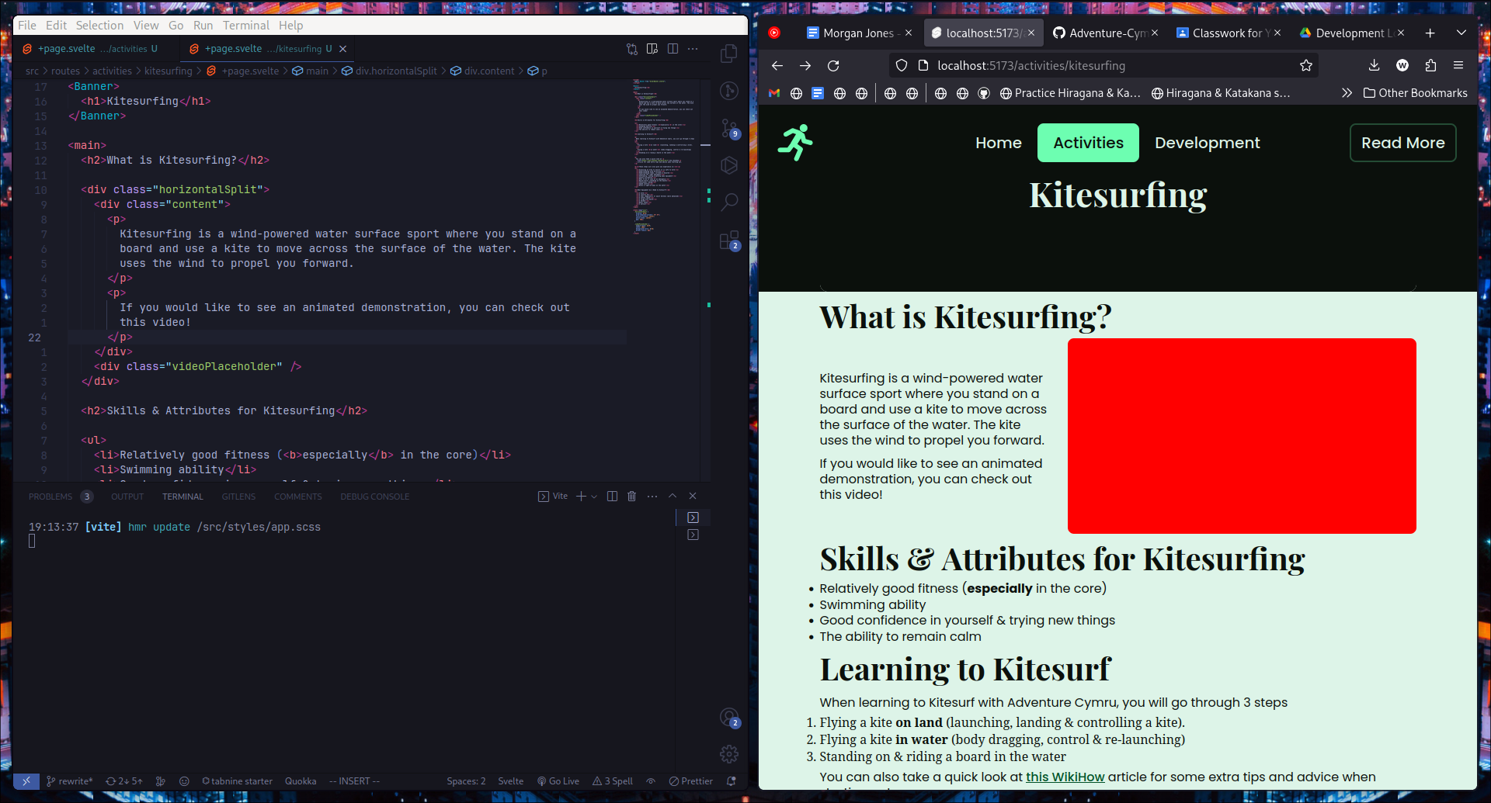

*Added video placeholder on Kitesurfing page*

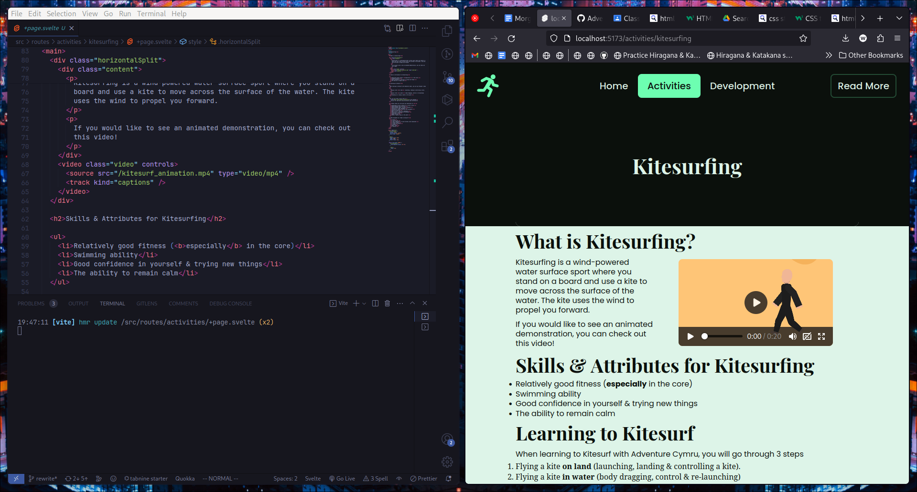

*Added video to Kitesurfing page*

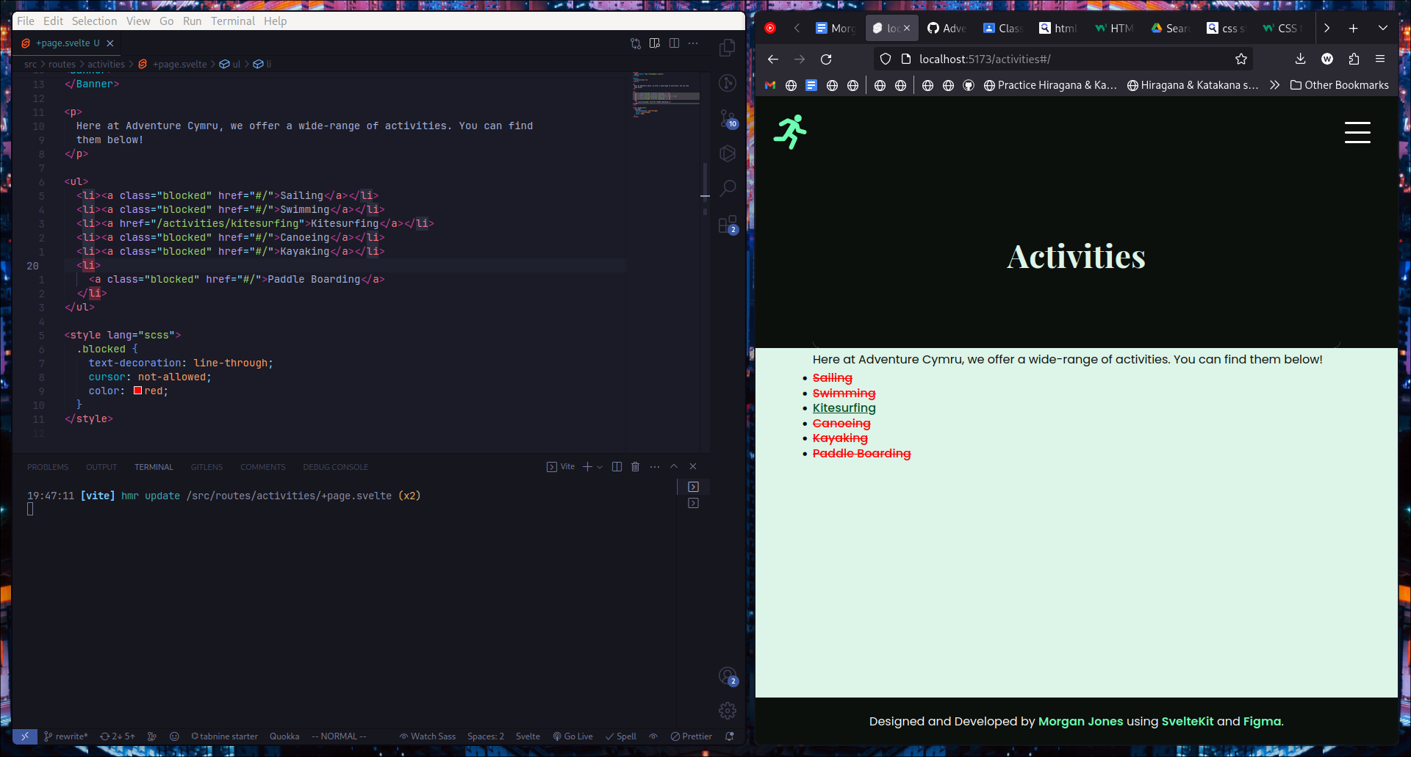

*Activities page with dummy links*

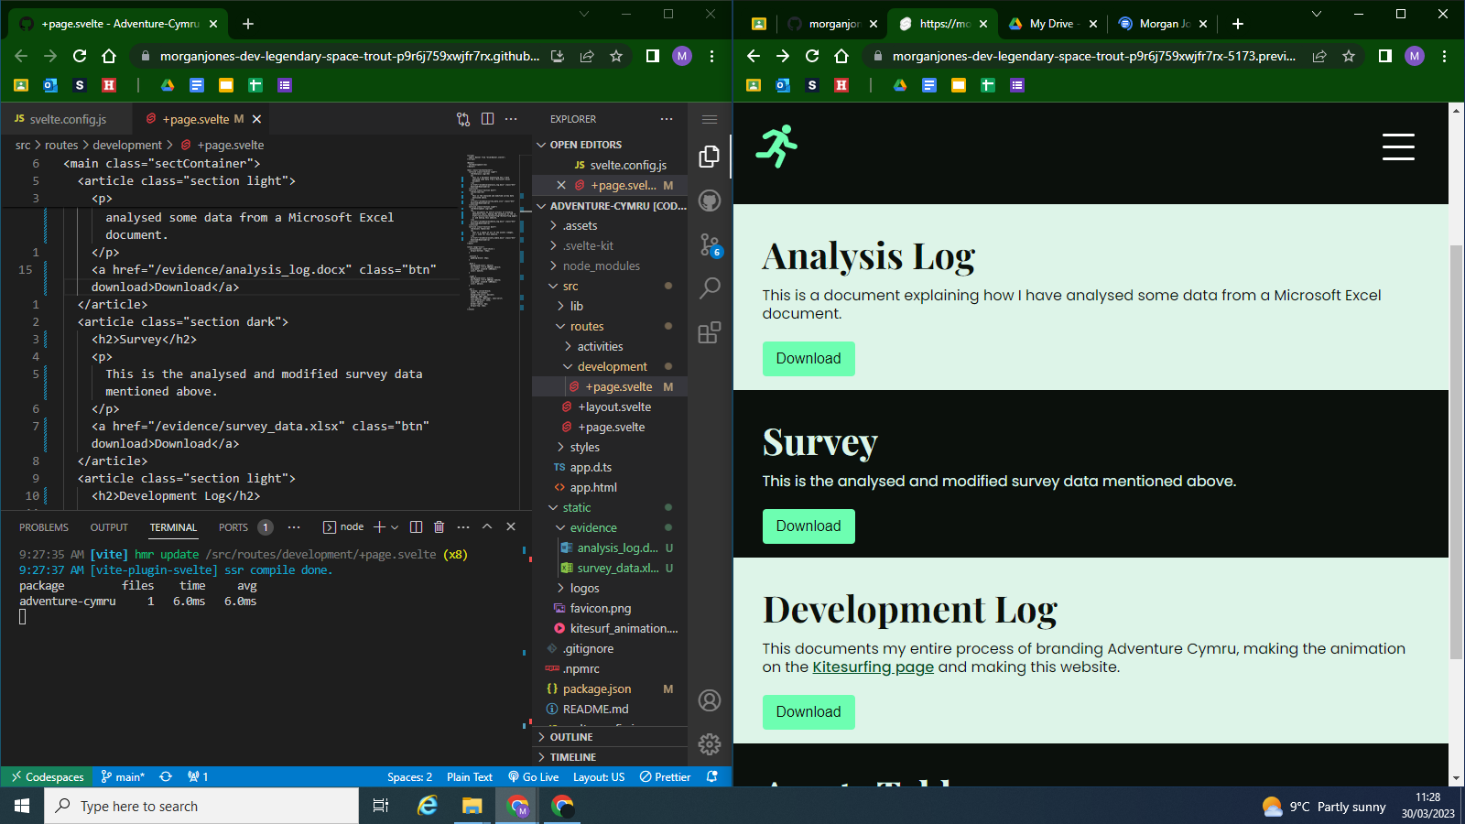

*Development page content + working download buttons*

# 3. Animation

## 3.1 Draft One

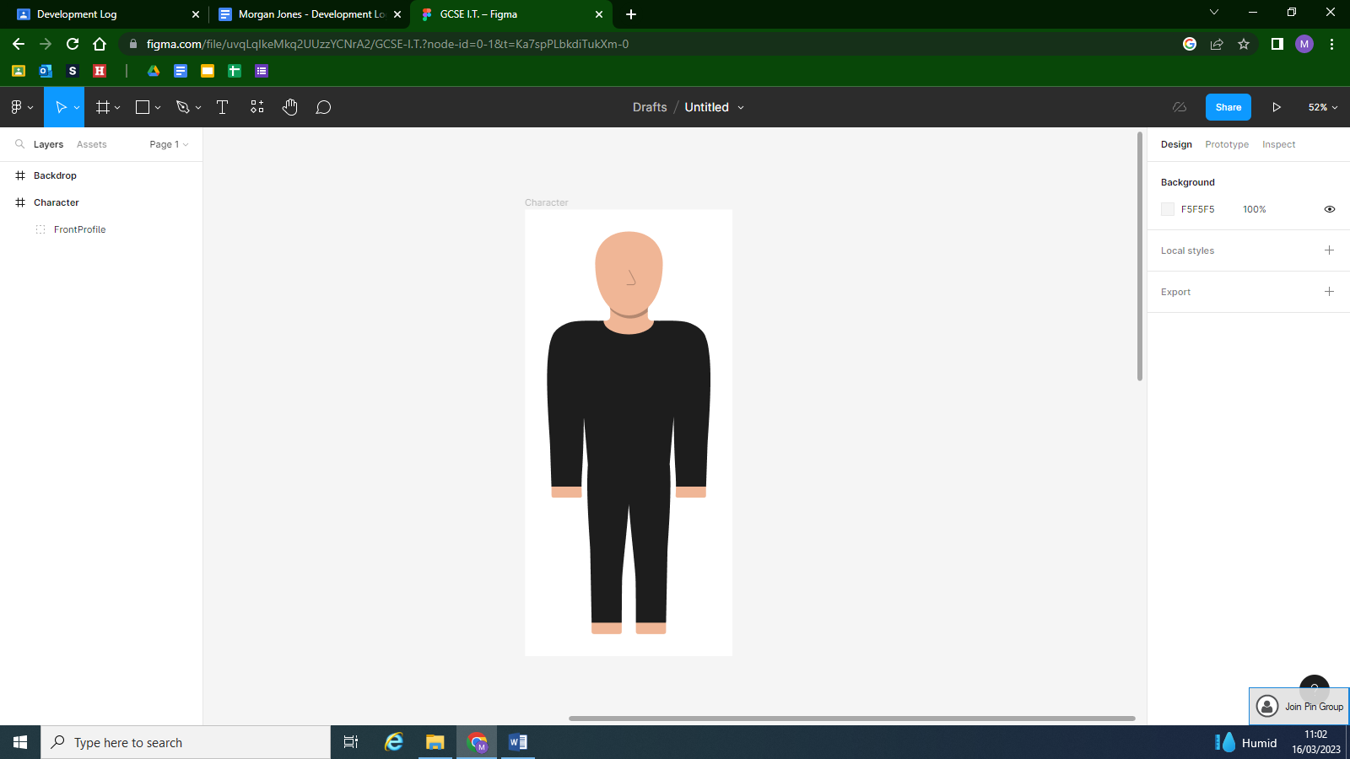

*Designed character front-facing view.*

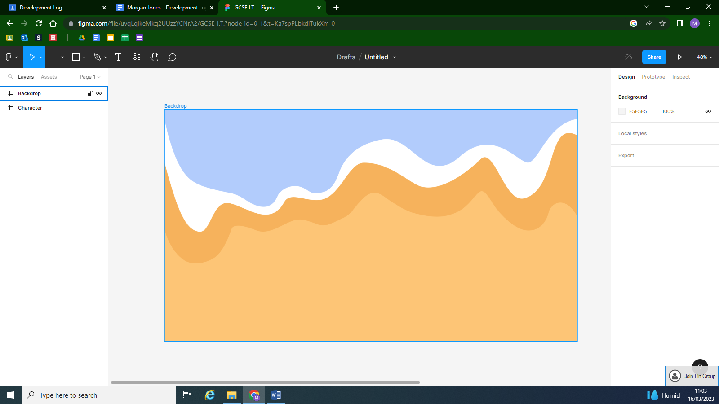

*Designed backdrop.*

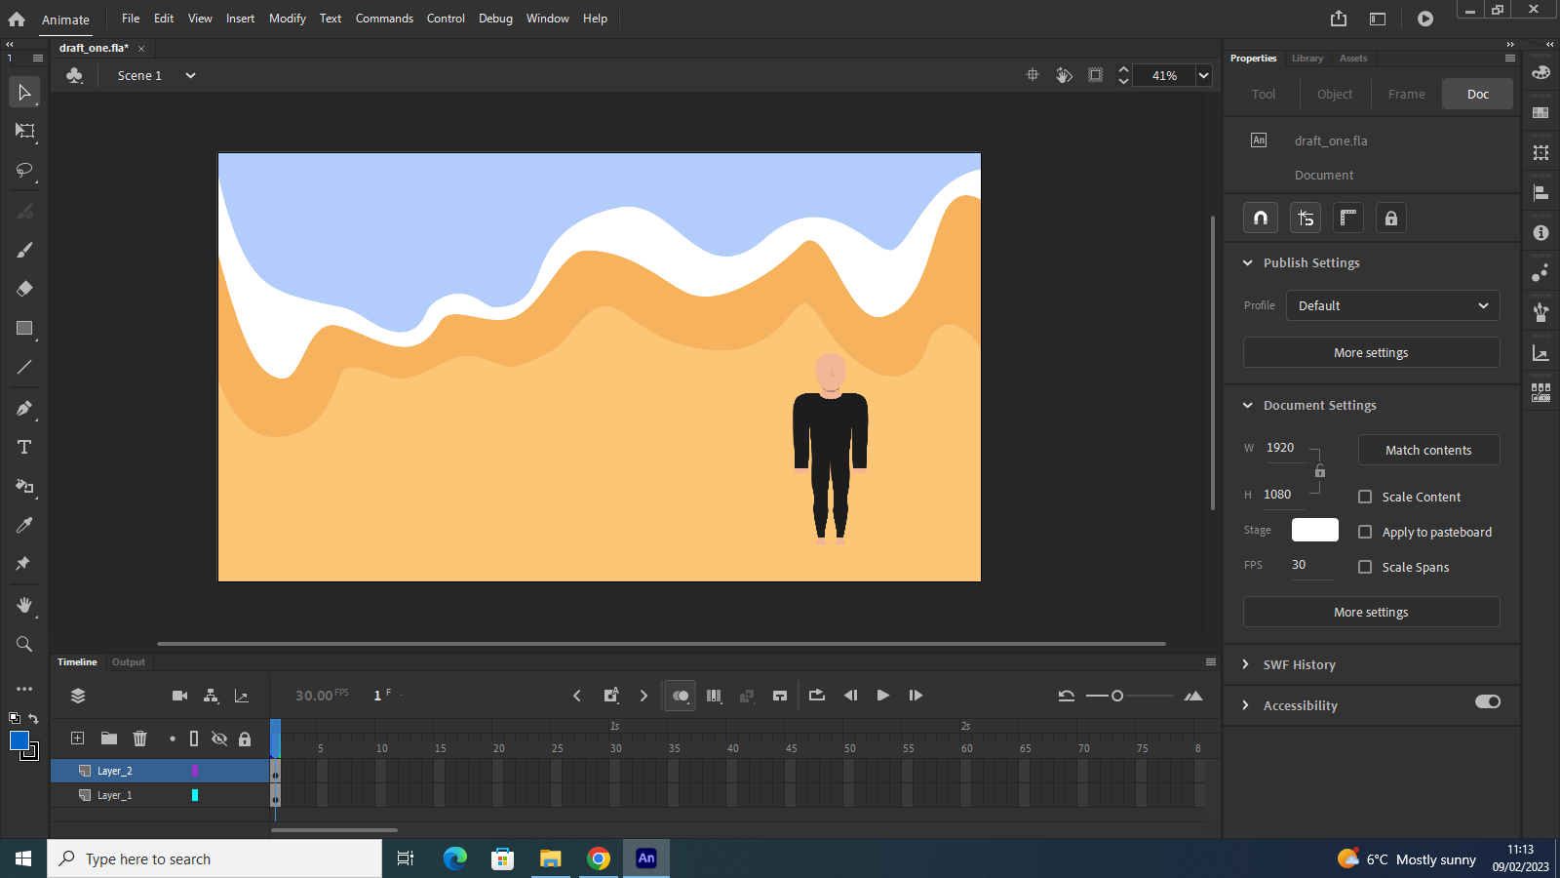

*Character assembled, backdrop in place in Adobe Animate*

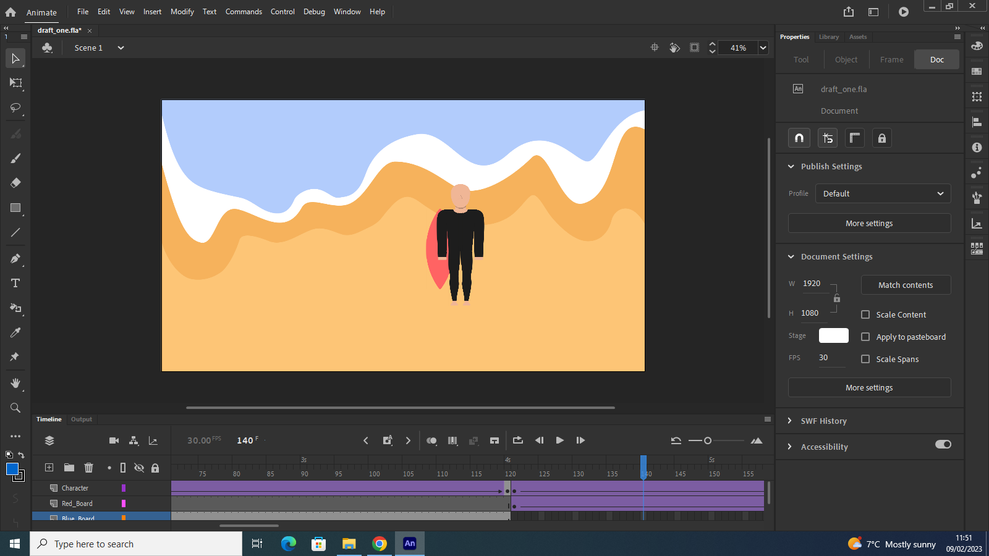

*Animated character getting kitesurfing board*

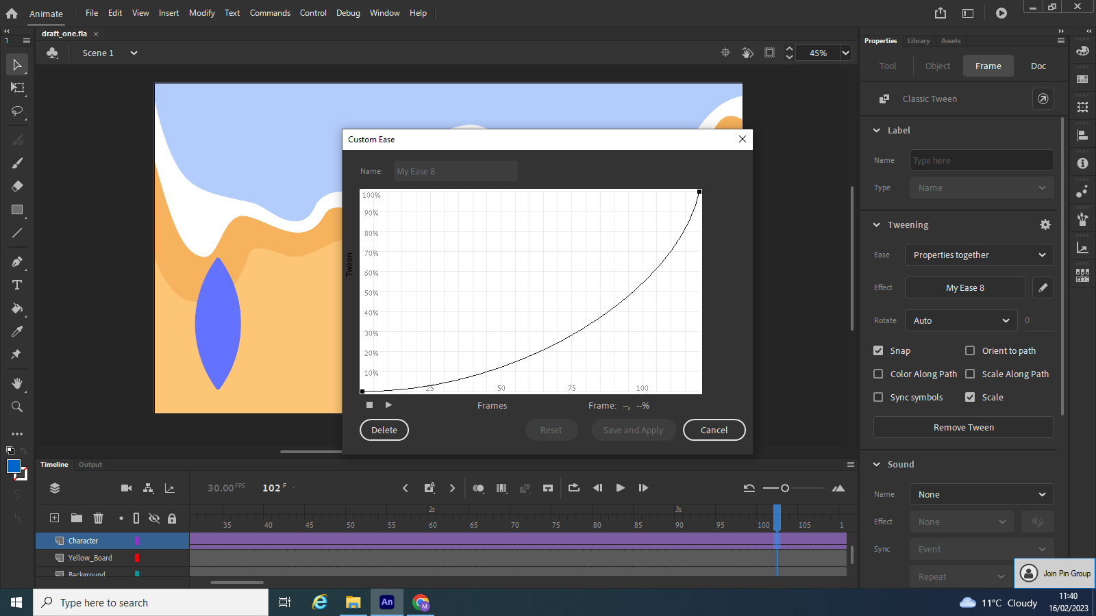

*Custom easing*

## 3.2 Draft Two

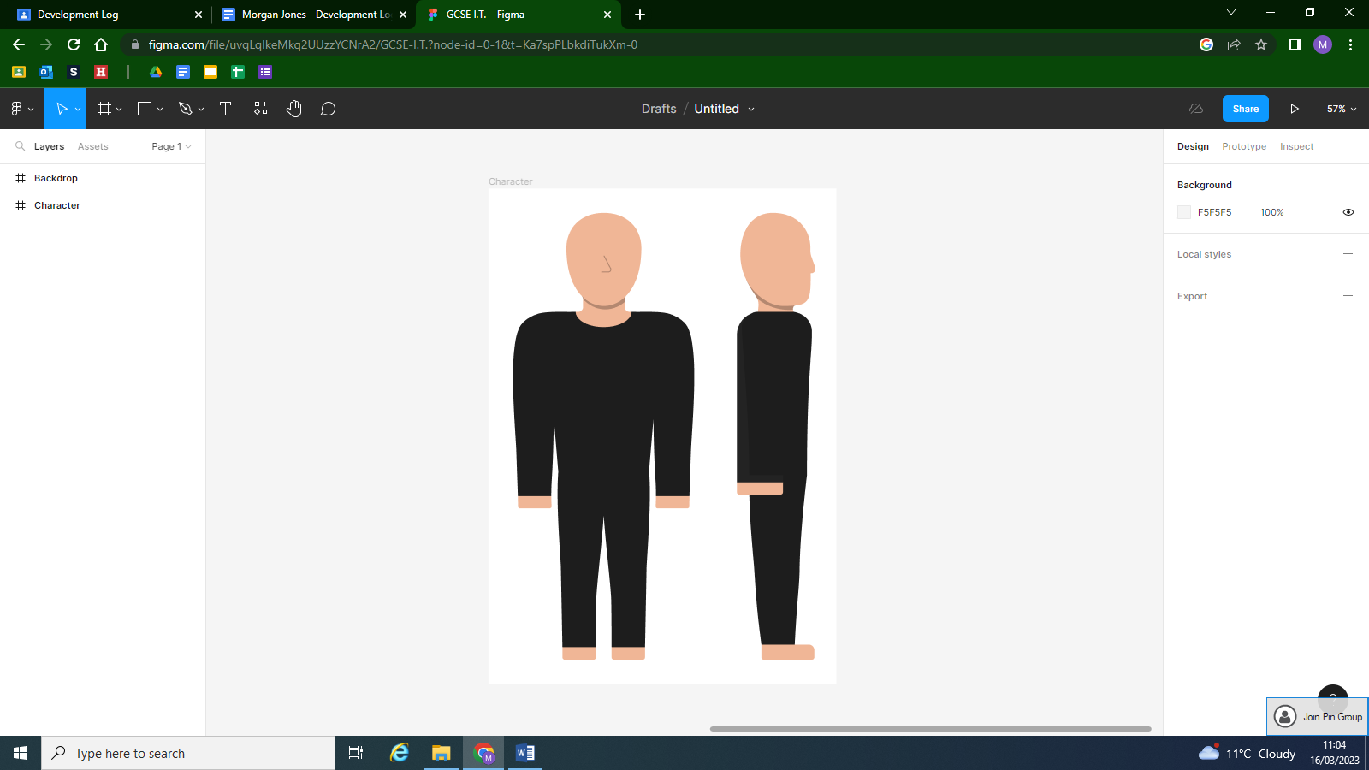

*Designed Character side profile for improved walking animation.*

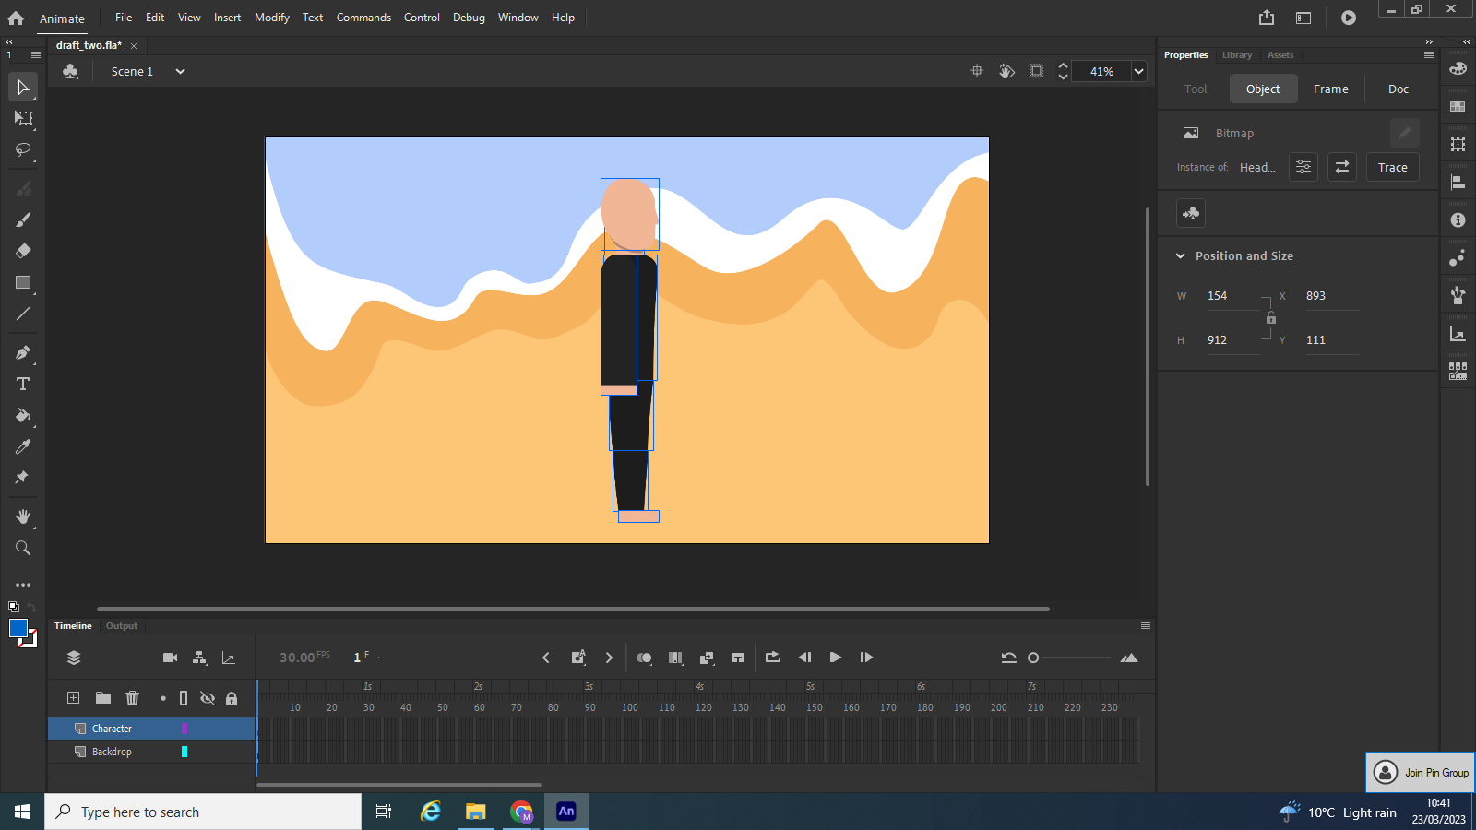

*Imported character*

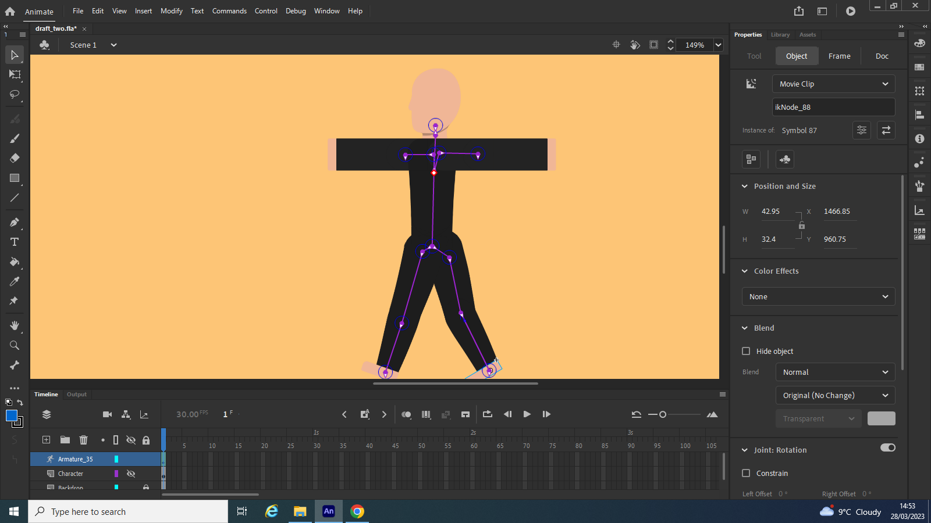

*Rigged character*

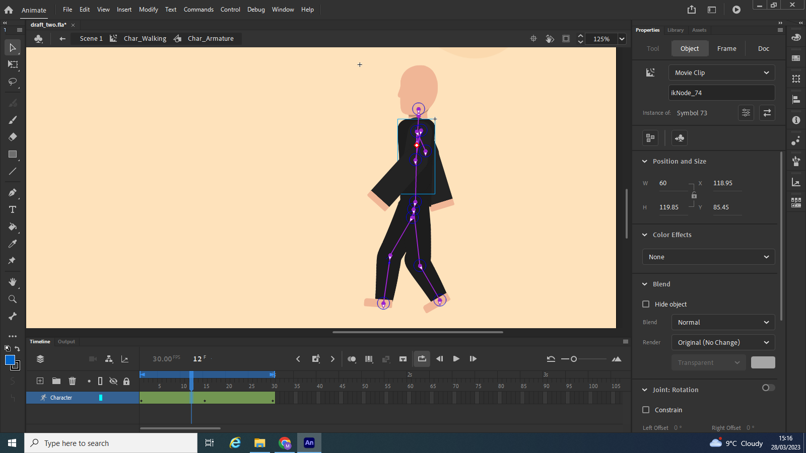

*Infinitely looping character walking animation with MovieClip*

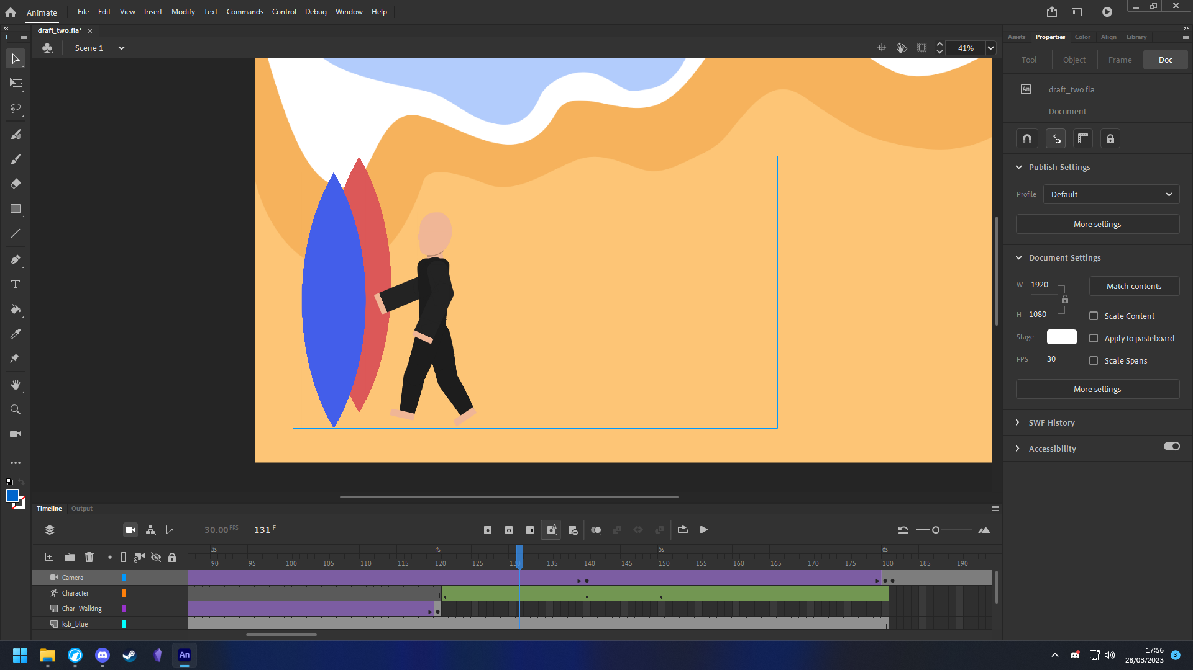

*Character picking up a Kitesurf Board, transition to water in next scene*

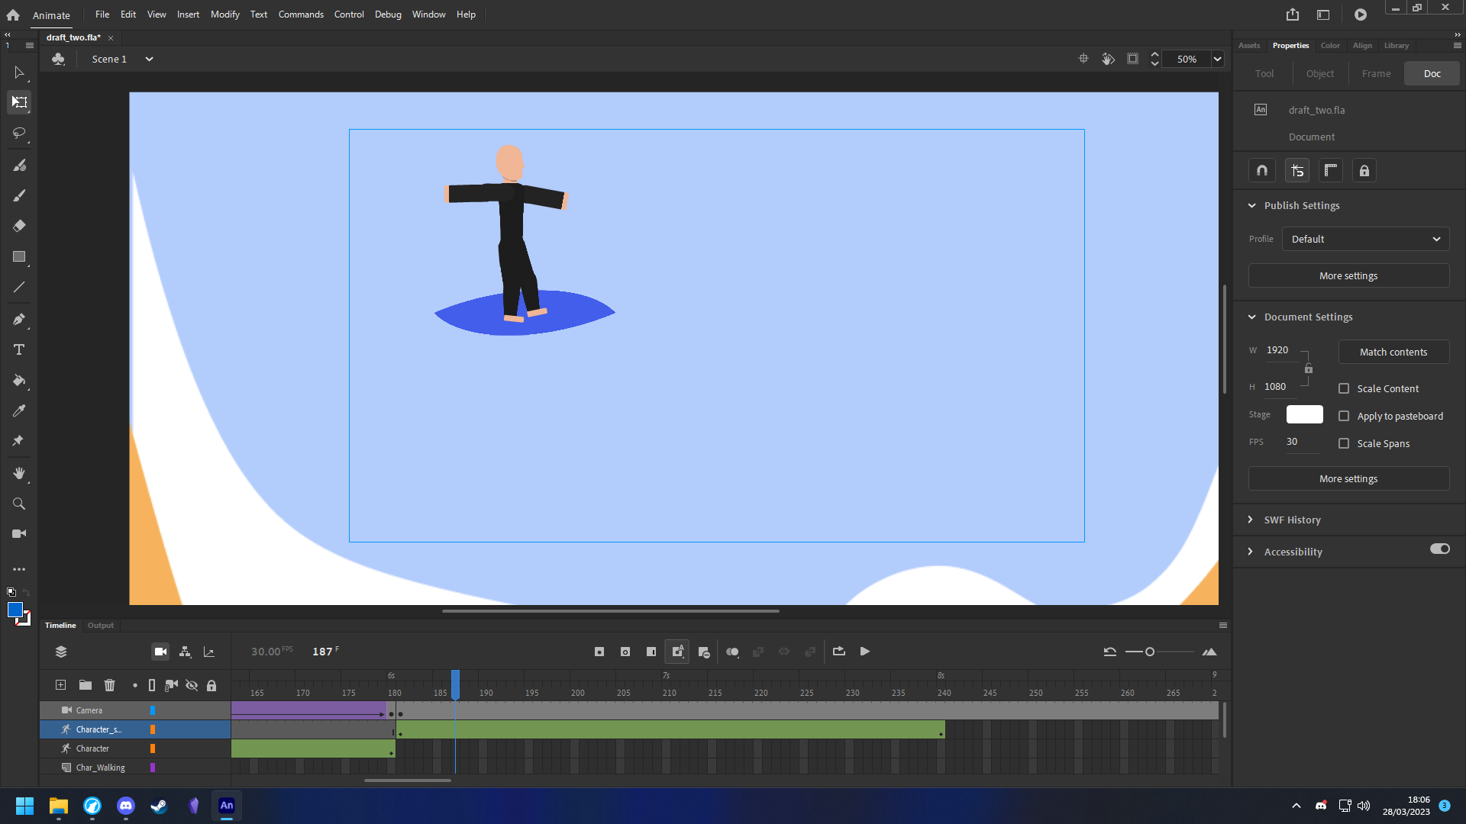

*Character on Kitesurf Board*

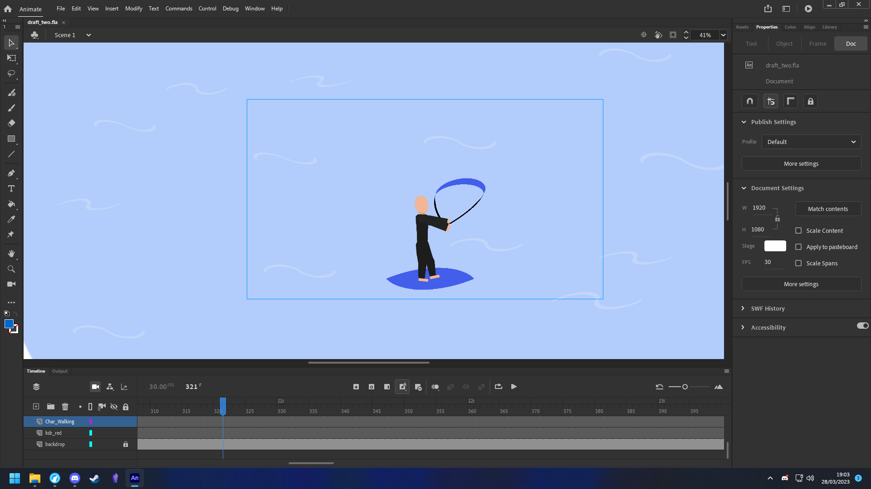

*Character on Kitesurf Board with Kite and waves*

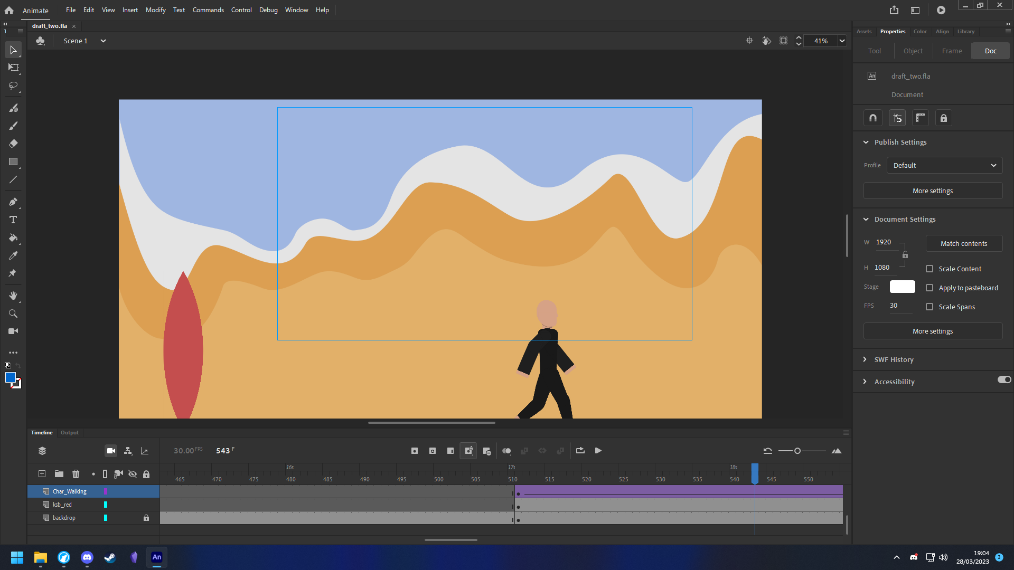

*Camera transitions from water to beach and fades out*